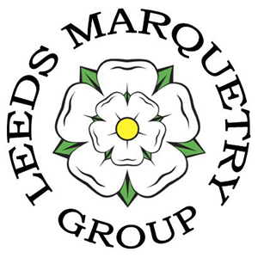LEEDS MARQUETRY GROUP

Project 2017
Three Veneers

The Club Project for 2017 is to make any item of marquetry (picture, coaster, box, tray, clock, . . .) but you are only allowed to use THREE VENEERS in the visible part of the project.
For clarification:
- non visible veneer (back of a picture, bottom or inside of a box) need not count as one of the veneers
- in the case of a picture, the framing veneer (edges and borders) counts as one of the three veneers
- an individual veneer with figuring or shading, or which includes both edge and heartwood, still counts as ONE veneer, ie it doesn’t have to be monochrome. However, in the spirit of the competition, this shading should be used to effect in single pieces of veneer (as in the background used in the ‘Camel Train’ picture below) rather than to covertly give additional ‘colours’ by using different parts of such a veneer in different parts of the item
- fragmentation can be used but using only the three veneers
- sand shading is allowable (as in the ‘Leaves’ picture below)
- TWO veneers could be used if so desired, ie a maximum of three veneers (as in ‘Pheasant’ and ‘Horse Head’ pictures below)
- Members can create more than one item if they wish

It is hoped that this project will be embraced by all members of the Club so that we have over fifty items produced.
Items entered in the Seaton Cup will go in the member’s usual category, but, if there are at least ten items (as is anticipated), a special additional category and prize will be awarded.
